*Login into your DragonFly Account. Click on your Child’s name. On the top right of the screen will be a “+” sign that says “Connect to School or Association”.

*Once you click on the “Connect to School or Association”. Then search for Ripley High School or add our school code: E89R3N
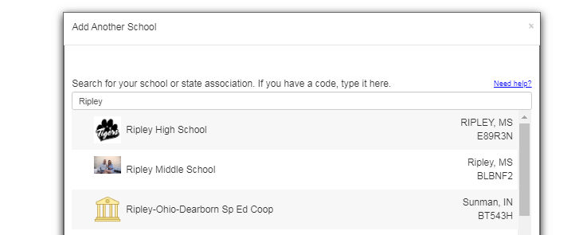

*This will connect you to Ripley High School & you’ll need to complete all of the required forms & update any health information.
Physical Examinations for the 2020-21 school year: Sports and activities physicals conducted on or after April 1, 2019, will be considered valid through May 31, 2021.
Students entering 7th grade, students who are new to participation in MHSAA sponsored activities, or students who are entering Mississippi from other states will be required to obtain a new pre-participation exam.

